http://en.wikipedia.org/wiki/Terrace_of_the_Leper_King

Terrace of the Leper King

&

Elephant Terrace
The Elepahnt and Leper-King Terraces in Angkor Thom
Just under 1000 feet long, the Elephant Terrace is made of carved sandstone; the stairways are buted with three-headed elephants. The carvings portray hunting scenes, with an emphasis on lions and tigers.
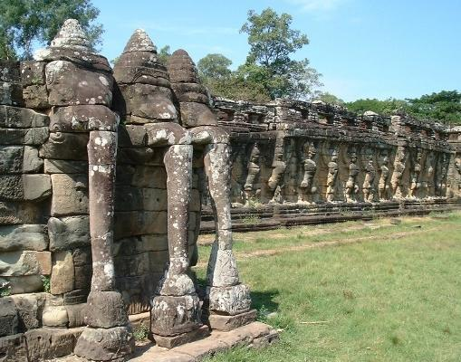
Picture Courtesy of Marc Dyer
The Elephant Terrace extends from the Baphuon to the Terrace of the Leper King. It is unclear today as to whether the three structures were connected or whether there was space between them, and, like the Baphuon itself, alterations were evidently made to both terraces.
The bas-reliefs of the Elephant Terrace, in addition to the hunting scenes present images of sporting events, including wrestling, chariot races, and a game that, though popular today in Europe, originated in Asia - polo.
The upper level of the terrace provides a view of the city walls. An area of it is carved with hamsas, or sacred geese.
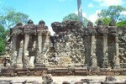
Picture Courtesy of Justin Watts
The background of the Terrace of the Leper King is shrouded in some degree of mystery. Speculation exists that at least a couple of Angkor's kings could have been lepers. Jayavarman VII, who constructed the Bayon and took the Khmer from Hinduism to Buddhism during his reign, is the leading candidate. But the terrace may be built simply to reflect Hindu legend.
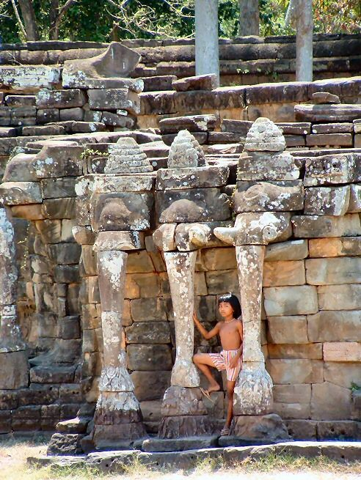
Picture Courtesy of Tom Rune Østby
The terrace is about 80 feet long and 20 feet high. It may have originally offerred access to some pools. A statue of the Leper-King sits at the terrace unclothed and a manner, with the right knee raised, that reflects Javanese influence. Though obviously nude, the Leper-King lack genitals. There is also no clear sign of the Leper-King's leprosy. The work is not outstanding and probably receives more attention for its place in Hindu literature than for the craftsmanship of the statue.

